Spcm lab 11

**Lab Exercise 11– Creating a VPC in Terraform Objective:**

**Objective:**

Learn how to use Terraform to create a basic Virtual Private Cloud (VPC) in AWS.

**Prerequisites:**

* Terraform installed on your machine.
* AWS CLI configured with the necessary credentials.

**Steps:**

1. **Create a Terraform Directory:**

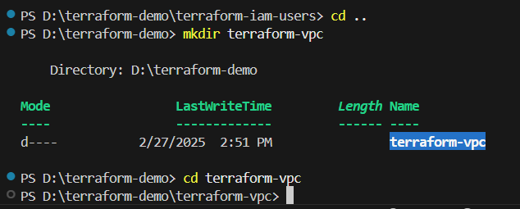

Vpc.tf

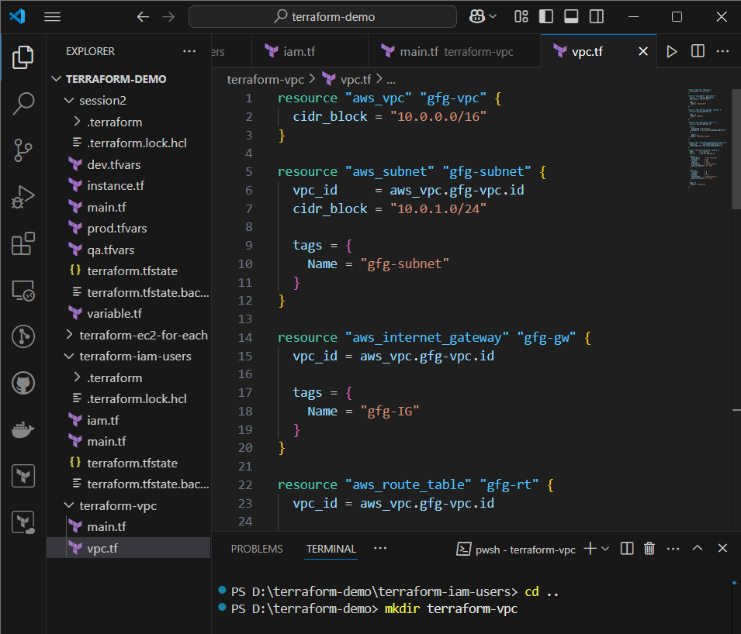

1. **Initialize and Apply:**

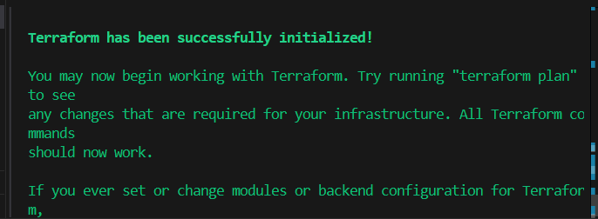

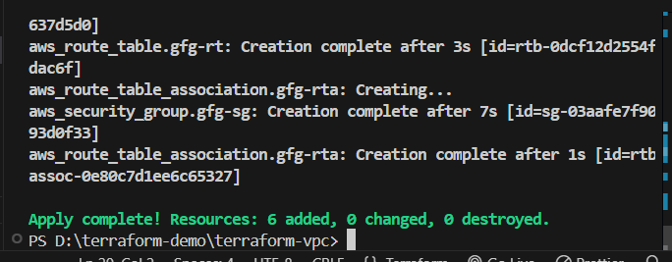

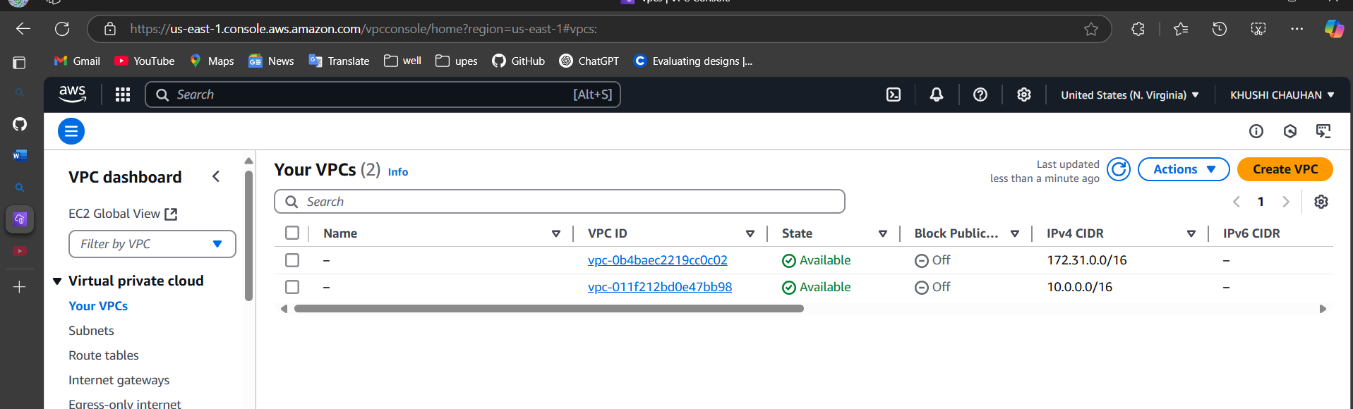

Destroy

